**AMARK RATINGS PRIVATE LIMITED**

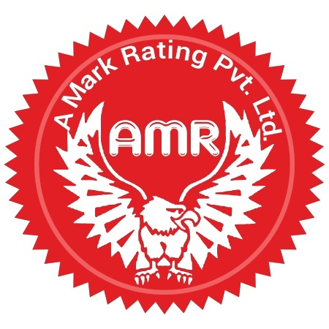

INSPECTION DIVISION, BHOPAL

**FEEDBACK FROM THE COMPANY THAT HAS BEEN INSPECTED/AUDITED**

1. Name of the Company:

2. Scope of Audit:

3. Date(s) of Audit:

**4. Performance rating**

|  |  |  |  |
| --- | --- | --- | --- |
| Clause | Particulars | Evaluation | |
| Yes | No |
| 4.1 | **Quality of Audit** |  |  |
| 4.1.1 | Did you get the Audit intimation sufficiently in advance? |  |  |
| 4.1.2 | Was the Audit carried out as per the programme? |  |  |
| 4.1.3 | Did the team leader brief you about the methodology of Audit? |  |  |
| 4.1.4 | Were the issues raised relevant, based on requirements / facts |  |  |
| 4.1.5 | Did the issues add value in terms of improving the company processes? |  |  |
| 4.1.6 | Did the Audit team evaluate your system sufficiently to come to a conclusion?  (Please highlight any key concerns missed out by the team) |  |  |
| 4.1.7 | Did the Audit team check relevant records to verify and collect evidence of compliance? |  |  |
| 4.1.08 | Was the Audit team impartial and fair in Audit? |  |  |
| 4.1.09 | Was the team knowledgeable about the standard and Audit techniques |  |  |
| **4.2** | Quality of Sampling |  |  |
| 4.2.1 | Were the representative samples taken by the Audit team? |  |  |
| 4.2.2 | Were the samples properly coded and counter signed by you representative? |  |  |
| 4.2.3 | Were the counter samples left with you? |  |  |
| **4.3** | Quality of communication and response |  |  |
| 4.3.1 | Were your communications replied to promptly? |  |  |
| 4.3.2 | Did you get sufficient info about the Audit before Audit? |  |  |
| 4.3.3 | Did you get the Audit reports in reasonable time from the date of Audit? |  |  |
| 4.3.4 | Were you satisfied with the speed of decision making by AMARK auditors? |  |  |

5. **General**

5.1 What would you suggest that we do differently?

5.2 **Overall service rating**

Excellent (5) Very Good (4) Good (3) Average (2) Poor (1)

**Note-Please send the filled up form to CEO inspection division in a sealed envelope.**

Name of company Representative:

Designation:

Date: